**Database Programming (CSD 4203_2)**

**Exercises 20-22**

**Name: Sakshi Jain Student ID: c0753352**

**Instruction: Provide FULL Screenshot of your code with the result on SQL Developer or SQL Live**

***Exercise 20 (1.2%)***

**Create a function called “get_job” that will accept job_id as parameter and return job_title. Invoke the function with the proper parameter.**

Code:

SET SERVEROUTPUT ON

CREATE OR REPLACE FUNCTION get_job (p_jobid IN jobs.job_id%Type)

RETURN jobs.job_title%Type IS

v_title jobs.job_title%Type;

BEGIN

SELECT job_title INTO v_title FROM jobs

WHERE job_id = p_jobid;

RETURN v_title;

END get_job;

--invoke the function

Variable b_title VARCHAR2(35)

EXECUTE :b_title := get_job('IT_DBA');

PRINT b_title;

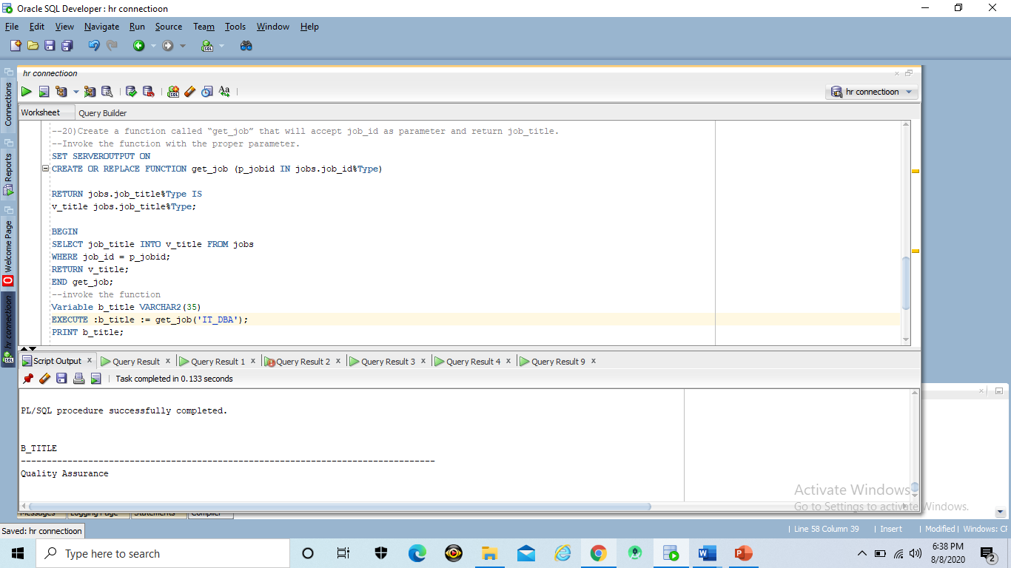

***Exercise 21 (1.2%)***

**Create function called “avg_sal” that will accept has department_id as parameter and return the average salary of the entered department id.**

Code:

SET SERVEROUTPUT ON

CREATE OR REPLACE FUNCTION avg_sal(v_deptid employees.department_id%TYPE)

RETURN NUMBER IS

v_avg_sal employees.salary%TYPE;

BEGIN

SELECT AVG(salary) INTO v_avg_sal

FROM employees WHERE department_id = v_deptid;

RETURN v_avg_sal;

END avg_sal;

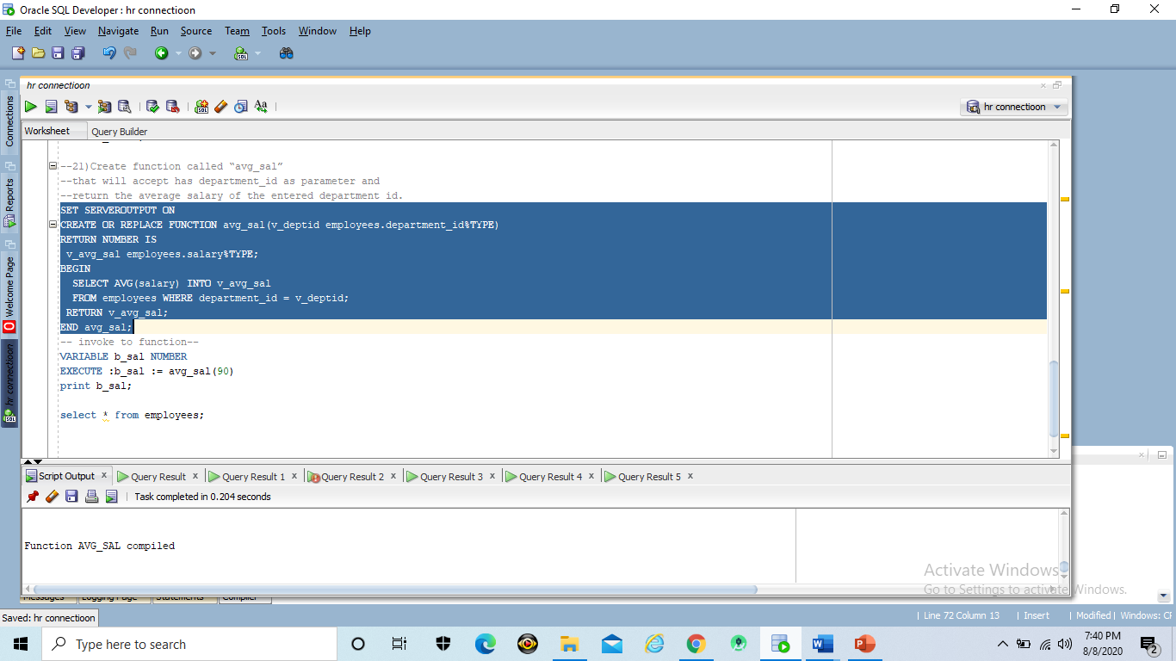

***Exercise 22 (1.2%)***

**Invoke the function you created “avg_sal” using proper parameter value**

Code:

VARIABLE b_sal NUMBER

EXECUTE :b_sal := avg_sal(90)

print b_sal;

